**System Design Document**

Dr. Brown Capstone Project Spring ‘24:

Portable Ultrasound Device for Coda-Wave Interferometry

Team members:

Michael Kisellus, Matthew Baker, Layton Foxworthy, Kyle Fox, and Christopher Coppedge

| Version | Author | Change | Date |
| --- | --- | --- | --- |
| v1.0 | Michael Kisellus, Matthew Baker, Layton Foxworthy, Kyle Fox, and Christopher Coppedge | Initial draft | 1/23/2024 |
| v1.1 | Michael Kisellus | Times new roman text, figure 6,7 update, print format to make more readable, update references, update table of context, table 2 update | 4Feb2024 |
| V1.2 | Kyle Fox | Updated readability | 5Feb2024 |
| V1.3 | Michael Kisellus | Corrections from SDD feedback | 15,20Feb2024 |
| V1.4 | Michael Kisellus | Same as above | 29Feb2024 |
| V1.5 | Kyle Fox | Update Software architecture sections | 01Mar2024 |
| V1.6 | Matthew Baker | Update cooling system detailed design, corrections from feedback on External Interfaces | 21Mar2024 |
| V1.7 | Matthew Baker | Corrections from TA feedback: eliminating stray highlighting, proofreading | 11Apr2024 |
|  |  |  |  |

TABLE OF CONTENT

1 INTRODUCTION 4

1.1 Purpose and Scope 4

1.2 Project Executive Summary 4

1.2.1 System Overview 4

1.2.2 Design Constraints 6

1.2.3 Future Contingencies 6

1.3 Document Organization 7

1.4 Project References 8

1.5 Glossary 8

2 SYSTEM ARCHITECTURE 9

2.1 System Hardware Architecture 10

2.1.1 Cooling System 10

2.1.2 Electrical System 11

2.2 System Software Architecture 12

2.3 Internal Communications Architecture 12

3 HUMAN-MACHINE INTERFACE 13

3.1 Inputs 13

3.2 Outputs 14

4 DETAILED DESIGN 15

4.1 Hardware Detailed Design 15

4.1.1 Environment Control and Cooling System 15

4.1.2 Electrical and Power System 16

4.1.3 Microcontroller and Control 17

4.1.4 Output Signal 17

4.1.5 Input Signal 17

4.2 Software Detailed Design 17

4.3 Internal Communications Detailed Design 18

5 EXTERNAL INTERFACES 19

5.1 Interface Architecture 19

5.2 Interface Detailed Design 20

6 SYSTEM INTEGRITY CONTROLS 20

7 References 23

SYSTEM DESIGN DOCUMENT

Overview

The System Design Document describes the system requirements, operating environment, system and subsystem architecture, files and database design, input formats, output layouts, human-machine interfaces, detailed design, processing logic, and external interfaces.

# INTRODUCTION

Bridges are vital transportation infrastructure that are used daily by millions of people. Like any constructed work, the material used has a finite lifespan and will degrade as both the effects of nature and its designed purpose act on the bridge. Being able to determine locations of failure points, subsurface cracks, and voids in building materials such as concrete can greatly increase the ability for an engineering team to predict future issues and plan remedial work for a bridge. To assist those engineers, the Portable Ultrasound Device (PUD) was designed. This device can be used in conjunction with ultrasonic transducers to detect anomalies within concrete. The data collected can be used to make future engineering decisions.

## Purpose and Scope

The PUD is a handheld ultrasound inspection device for inspecting bridges and structural components for faults in the field. This handheld unit will have an independent power supply and will collect and store test data. The PUD is fully capable of its precise data collection duties while still being durable enough to withstand difficult environmental conditions such as shock from a fall, rain, and other environments a field tool will be exposed to.

## Project Executive Summary

This PUD unit consists of commercial off-the-shelf (COTS) components engineered into a cohesive system that matches the requirements. The production management for the PUD project is Agile Scrum. Dividing the PUD project into 3 sprints over the course of an 11-week timeline.

### System Overview

The PUD system will output a pulse signal to the transducer as shown in figure 2 point 1. The transducer then uses the piezoelectric effect to produce a 54kHz test signal, this signal propagates into the connected concrete sample being tested. The signal then propagates to a second transducer placed on the opposing side of the concrete sample. Through the piezoelectric effect the second transducer converts the 54kHz signal into a low-level voltage which is returned to the PUD to be processed.

Note: The 54 kHz is due to the manufacturer of the transducer NDT James Instruments. It is designed to produce this frequency

The use case diagram shown in figure 1 describes the options an operator can use to operate the PUD system. The operator may charge the battery or remove the storage device (SD) card when the power is off to the main system. The main functionality is accessible when the operator turns the unit's power on. Allowing the operator to enter the test duration by repeatedly pressing the test duration button to cycle through the options. The test duration selected is displayed on the face plate LEDs 6,7,8,9, and 10 shown in figure 6. The operator may press the start button to initiate the test. The operator may also stop the test before the test duration ends and save the resulting data to an SD card.

Figure 1: Use Case Diagram

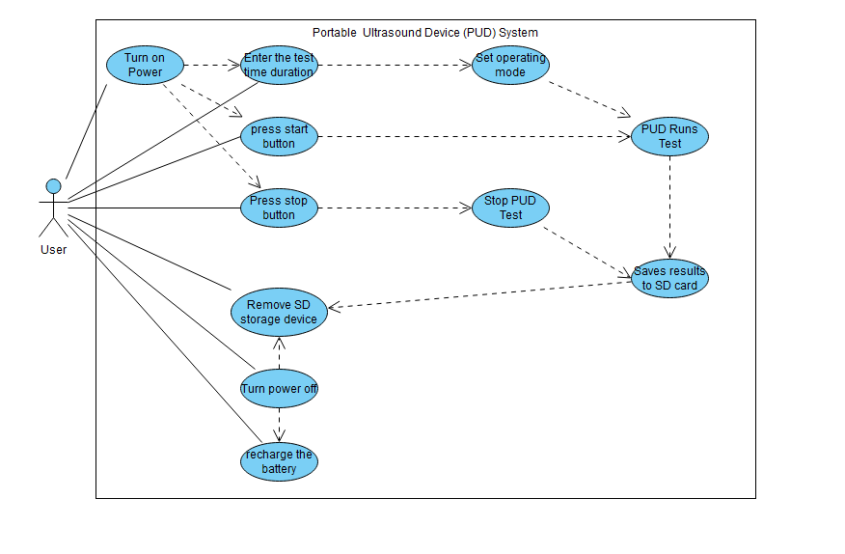

Figure 2: overall system diagram

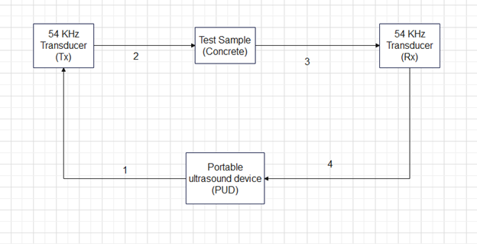

### Design Constraints

The design of the system will balance system weight vs battery life, battery consumption vs cooling, and accuracy vs component price. One of the requirements of the system is that it must remain portable and as such we will be keeping the unit as light as possible. This comes in direct competition with battery life, which also has its own requirement. Battery consumption and cooling are also going to have to be balanced to ensure the hardware, specifically the battery, stays within operating temperature. This would lead us to running the fans more but that increases battery consumption and decreases how long the system can be used in the field. Lastly, more accurate signal processing hardware costs more than its less accurate counterpart so our design uses components that are within the project’s budget of $2000 and are also accurate enough for our application.

### Future Contingencies

The exact requirements of the system are dependent on the civil engineering laboratory (Lab run by Professor Brown), which serves as the primary stakeholder for the system. They will be the primary user of the PUD once it is operational so the requirements must match their expectations. Any changes to the system will depend on their wants and needs. The civil engineering lab already has some components of the final system, these are not going to change and are proven to operate correctly from previous testing.

Operating with 500V requires specialized components and rated insulative material to protect the system from inadvertent grounds or component failure. If components fail during testing a higher voltage rated component may be purchased to replace insufficient performing parts.

The Metal oxide semiconductor field effect transistor (MOSFET) component used must switch on and off quickly to fulfill its purpose. If the component is unable to meet specifications during testing a better/ more expensive component may need to be purchased to replace this component.

The oscilloscope used to sample the return signal needs to be sampled extremely quickly to capture the return signal in detail. This component may need to be replaced if testing reveals the sample rate to be insufficient.

## Document Organization

The document adheres to the organizational structure and formatting prescribed by the course. Every section, heading, and subheading has been aligned with the template guidelines to maintain a consistent and professional appearance. By following the provided instructions and formatting guidelines, we aimed not only to meet the basic requirements but also to contribute to the overall uniformity of documentation between the multiple teams. This approach ensures that the professors and TAs can easily navigate the document.

Part 1 contains the INTRODUCTION which has 8 subsections: Purpose and Scope, Project Executive Summary, System Overview, Design Constraints, Future Contingencies, Document Organization, Project References, and the Glossary. Overall, this section describes the system, constraints, contingencies and the documentation associated with the system.

Part 2 contains the SYSTEM ARCHITECTURE which has 3 subsections: System Hardware Architecture, System Software Architecture, Internal Communications Architecture. Overall, this section describes the system hardware and software architecture for the PUD system. The hardware section is subdivided by systems.

Part 3 contains the HUMAN-MACHINE INTERFACE which has 2 subsections: Inputs and Outputs. Overall, this section describes the inputs a user can make and the outputs the PUD system will produce.

Part 4 contains the DETAILED DESIGN which has 3 subsections: Hardware Detailed Design, Software Detailed Design, Internal Communications Detailed Design. Overall, this section provides an in-depth explanation of the systems used to construct the PUD system.

Part 5 contains the EXTERNAL INTERFACES which has 2 subsections: Interface Architecture and Interface Detailed Design. Overall, this section describes other systems the PUD system must interface with to operate. This section is small because the system is self-contained and does not communicate to exterior systems during operation.

Part 6 contains the SYSTEM INTEGRITY CONTROLS. Overall, this system has to do with data security and software protection. This section is small due to the unit not requiring data protection as the PUD does not contain sensitive information.

## Project References

This section provides a bibliography of key project references and deliverables that have been produced before this point.

International Electrotechnical Commission (2013). Degrees of protection provided by enclosures (IP Code) (IEC 60529). Retrieved from https://website.iec.ch/publication/2452

Parts references are placed at the end of the document in table 3.

## Glossary

Supply a glossary of all terms and abbreviations used in this document. If the glossary is several pages in length, it may be included as an appendix. Shown in table 1.

Table 1: glossary

| IP Rating [IPAB] | Ingress Protection rating as codified under the IEC 60529 standard, where A is the device’s resistance to solid particle such as dust from zero (no protection) to 6 (most protection) and B is the device’s resistance to liquids from zero (no protection) to 9K (most protection). (International Electrotechnical Commission [IEC], 2013)  An IP55 rating means:  5-Ingress of dust is not entirely prevented, but it must not enter in sufficient quantity to interfere with the satisfactory operation of the equipment.  5-Water projected by a nozzle (6.3 mm) against enclosure from any direction shall have no harmful effects. |
| --- | --- |
| PUD | Portable ultrasound device |
| LED | Light emitting diode |
| piezoelectric effect | Applying mechanical stress to a crystal produces an electrical charge and vice versa. |
| MOSFET | Metal oxide semiconductor field effect transistor |
| UART | Universal asynchronous receiver transmitter |
| HMI | Human machine interface |
| PC | Personal computer |
| Tx | Transmitter |
| Rx | Reciever |
| SD | Storage device |
| FRD | Functional requirement document |
| RTM | Requirement traceability matrix |

# SYSTEM ARCHITECTURE

This section outlines the overall system architecture, including both software and hardware architecture for the PUD system and subsystems.

Figure 3 shows the PUD physical components and their interactions. Point 1 shows that the cooling fan receives power to operate from the battery. Point 2 shows that the analog to digital converter delivers its data to the central control chip. Point 3 shows that the pulse generator is controlled by the central control chip. Point 4 shows that the pulse generator controls the MOSFET gating on or off. Point 5 shows that The MOSFET outputs to the Transducer. Point 6 shows that the central control chip transfers data to the SD card. Point 7 shows that the central control chip monitors the battery voltage. Point 8 shows that the cooling fan is controlled by the central control chip. Point 9 shows that the status LEDs are controlled by the central control chip. Point 10 shows that the central control chip receives power from the battery. Point 11 shows that the status LEDs are powered by the battery. Point 12 shows that the transducer transmits a signal to the analog to digital converter. Point 13 shows that the MOSFET input is provided by the DC-to-DC converter. Point 14 shows that the DC-to-DC converter is powered by the battery.

Figure 3: Portable ultrasound device (PUD) internal components block diagram

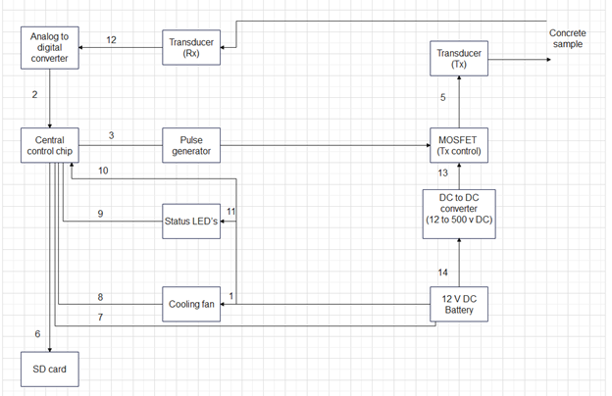

## System Hardware Architecture

This section, describes the overall system hardware and organization. The system hardware is broken into 2 subsystems: Cooling System, Electrical System.

### Cooling System

The cooling system consists of multiple 80mm fans each connected to an integrated fan controller and temperature sensor to operate independently from one another to ensure that if one fan goes down the other(s) can still operate as well as making sure each area within the case gets the airflow that it requires. The fans will be placed on either end of an inner metal frame to drive the airflow over the components in the most efficient manner possible. The fan’s RPM rate will be tied to the internal temperature of local components (detected via the controller) via the following curve shown in figure 4. This curve is designed by the manufacturer of the fan components.

Figure 4: Cooling fan behavior chart

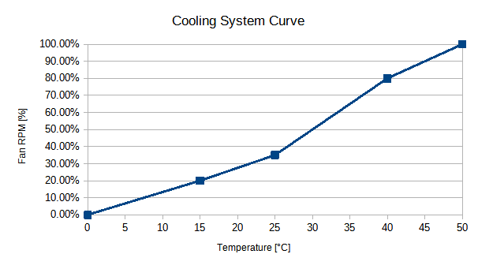

While the system’s design considers the possibility for the fans to run at maximum for the entire operating time, this thermal curve is in keeping with industry standards for keeping a computer system cooled while preventing too much current and power use from the internal power supply and thus preventing premature power drain.

Parts List:

* Twin NMB 08025SE-12Q-FT-DW Fan, 12VDC, 3.12 Watts at 0.26 Amps for variable cooling
* EMC2101 integrated fan controller and thermocouple, 3/5V DC connected to central board.

### Electrical System

The PUD electrical system consists of a 12v battery bank which is used to power various loads. Such as LED’s and cooling fans. There is a subsystem for charging the battery which is disconnected through an externally operable switch. The high voltage section consists of a 12v DC to 500v DC converter and a capacitor bank to maintain voltage. Electrical schematic shown in figure 3 below.

Parts list for electrical systems are shown in table 2 but parts may be replaced with equivalent parts.

Figure 5: PUD Electrical system

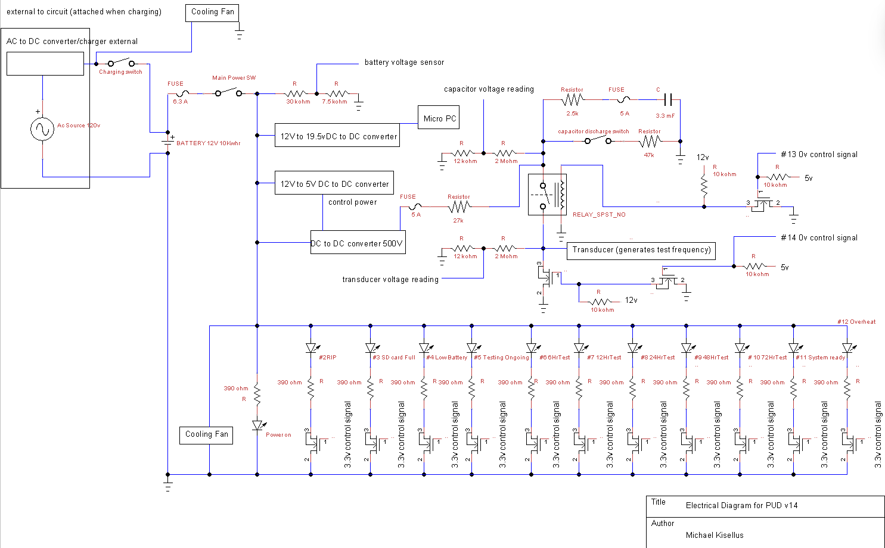

## System Software Architecture

The software system is made up of two parts, the Raspberry Pi Pico, and the minicomputer. Both parts work independently to control the system and record data.

The Raspberry Pi Pico (RP Pico) handles system control through a state machine with three separate states. Each state controls a different part of the hardware system. The first state allows for button interrupts to control movement to the next state. The second state allows for pulse control and overall system timing. The third state changes the total test time of the system.

The microcomputer will run a Python-C wrapper to program the oscilloscope to do automated data collections. This collection will be done without human intervention and store the data on an SD card within the computer for later retrieval.

## Internal Communications Architecture

The internal communications will consist of USB, Digital IO, and UART. The Universal asynchronous receiver transmitter (UART) will allow us to program the microcontroller. USB will be used to control and program the Oscilloscope as well as preform data collection/storage. The microcontroller will use the digital IO pins to control the Human machine interface (HMI) and pulse control. Shown in figure 8.

There will be no communication between the microcontroller and the minicomputer as the buttons will control microcontroller function and the oscilloscope will have automatic data collection. The microcontroller will however send a pulse to the oscilloscope at the same time as the control pulse is sent to the transducer.

Figure 8: Internal Communications Architecture diagram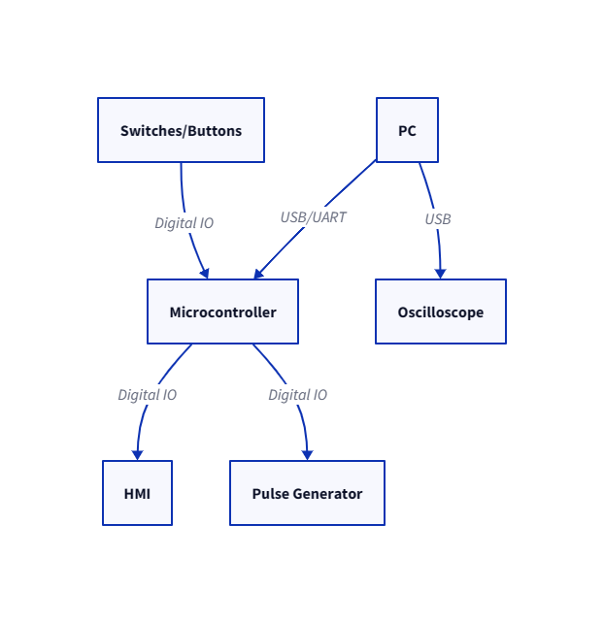

# HUMAN-MACHINE INTERFACE

The PUD system will have input from the user to start the system and to determine how long the system should operate. This will be performed through physical buttons. As for outputs the PUD will have LED indicators to display the system’s status to the operator. Additionally, a removable SD card will be able to be extracted from the system after it has gathered the desired data.

## Inputs

The PUD system inputs will be physical buttons that send a voltage signal to the microcontroller. Because it is a simple 2-state button the PUD will have the input to the microcontroller be a simple binary input. The buttons will correspond to modes that set the time the system will be in operation. This simplicity will make I/O controls simple and reliable.

The front panel physical button I/O options will be “Test System”, “6 Hour”, “12 Hour”, “24 Hour”, “48 Hour”, “72 Hour”, “Start Test” “Select Test Duration” and “Stop Test”. As shown in figure 6.

Figure 6: Input panel for PUD

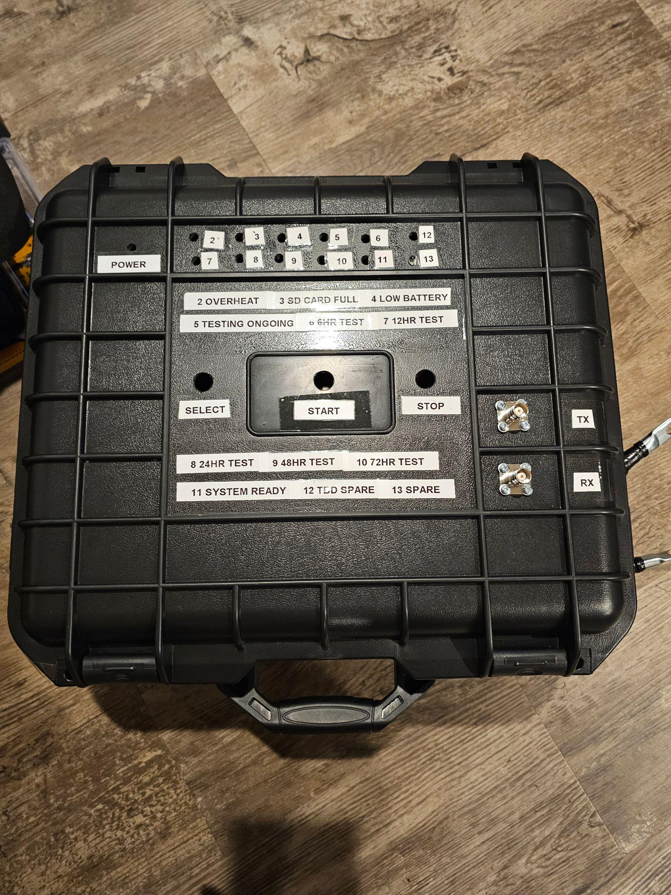

## Outputs

The outputs from the system come in two different forms. The data from the operation of the system, and the indicators that tell the operator the status of the system. The operator indicators will be presented on LEDs and the system’s output data from the concrete measurement will be stored on an SD card.

The operator’s indicators will be the representation of binary values in our microcontroller. The implementation of this will depend on the voltage the microcontroller is able to output so if it is not able to power the LED we may need a relay to switch the LED on. The indicators will include “Power Available”, “Low Battery”, “High Temperature”, “SD Card Full”, “Unit Charging Capacitor” and more if needed.

The data the system collects about the concrete will need to be converted to a digital signal and stored through the oscilloscope. This will then be written to an SD card in the minicomputer for the operator to retrieve when the system is done with its operation. The retrieval will require the case to be opened. This helps protect the SD card against the weather. The output file on the SD card will be set within the minicomputer program as a “.mat” file.

Note: Expanding on the source of the data the system collects: After the system transmits a 500 v pulse to the Transmitting (Tx) transducer. The transducer vibrates and those vibrations travel through the concrete/sample. The vibrations then reach the receiving (Rx) transducer and the vibrations are converted to a electrical voltage. This voltage is read by the connected oscilloscope and processed into a graph of the resulting voltages over time. This graph is then saved for review by human operators on a removable SD card or other storage device.

Figure 7: Output panel for PUD



# DETAILED DESIGN

This section provides the information needed for a system development team to build and integrate the hardware components, code, and integrate the software modules, and interconnect the hardware and software segments into a functional product. Additionally, this section addresses the detailed procedures for combining separate COTS packages into a single system. Every detailed requirement should map back to the Functional requirement document

(FRD), and the mapping should be presented in an update to the Requirement traceability matrix (RTM) and include the RTM as an appendix to this design document.

## Hardware Detailed Design

The low-level hardware design is split into 5 distinct parts. The microcontroller and control system, the output signal, the input signal, the environment control, and the power system.

### Environment Control and Cooling System

The cooling system consists of two 80mm 12VDC fans each connected to a EMC2101 fan controller which circulates air via a pull-push arrangement with one fan acting as intake and the other acting as exhaust. The fans are placed on opposing sides of the case and staggered with one at the rear-right and the other at the front-left side to properly vent air around the battery and capacitor. The fan controllers are integrated circuit boards that contain a programmable ROM that contains a look-up table which instructs the fan on the proper RPM to spin at via pulse-width modulation which is dependent on the temperature inside the case. The external cutouts for the fans have fan covers that consist of an external vent to protect from rainfall; filter media to prevent the ingress of dust, insects, and other solid matter; and a plastic grate to act as a finger guard in the event that the external cover is dislodged. Internally the fans are protected via plastic mesh held to prevent damage to the internal wiring. Each fan as an IP55 rating to aid in the overall elemental resistance of the unit. The fan cover baseplates are attached via long screws and waterproof sealant. Each fan draws 3.12 watts and 0.26 amps and each controller board requires 5VDC supply voltage provided by available power within the electrical system. The fan controller boards also provide the temperature readings to the Pico at the heart of the system so that, in case of temperature overrun, the system can be shut down to prevent damage to the components.

### Electrical and Power System

The electrical system consists of 2 main buses. Note: electrical bus bars are used to distribute power. A 12 V DC bus and a 500 V DC bus are used.

The 12 V DC bus consists of 2 loops. The first loop is used to recharge the LiFePO4 12V 50Ah Lithium Iron Phosphate Battery. The battery is connected using 6 AWG (16mm²) 13 Inch Battery Interconnect Cable to the exterior of the casing and is accessible without opening the case. A Battery Isolator Switch for Car Vehicle RV and Marine (On/Off) is used to isolate the battery charging loop when not in use. The battery charger used is a 5A & 10A 12V Smart Battery Charger with LCD Display for Lead Acid and Lithium (LiFePO4) Batteries. The second loop connects the battery to the 12 V DC load bus which powers the various loads of the system. The battery has a switch to open this loop and turn off the system. The battery connects to the 10 Position Wire to Board Terminal Block Horizontal with Board. This is used to connect the various 12 v loads. Including the LED indicating lights which require a 453 Ohms ±1% 0.25W, 1/4W Through Hole Resistor Axial Metal Film to reduce voltage and current to 3.3v and 20mA for the LED to operate. The LED uses a Transistor’s: Bipolar (BJT) Transistor NPN 36 V Through Hole TO-92-3 to receive signals from the controlling chip to turn on or off. The cooling fan receives power from this bus. The controlling chip receives its power from this bus. The DC 12v 24v to 5v Step Down Converter Regulator 5A 25W Power Adapter Reducer for Car Electronics Truck Vehicle Boat Solar System (Accept DC 8-40V Inputs) receives power from this bus and its output is used as control power on the Enclosed DC to DC Converter 1 Output 0 ~ 500V 20mA 13V Input. The 12V DC to 500V DC converter receives its main power from this bus and sends power to the 500V bus.

The 500V DC bus starts at the 12V DC to 500V DC converter and is used to charge a 3300 µF 500 V Aluminum Electrolytic Capacitor which acts as a voltage regulator for normal operation. Amcor Marine Grade Primary Wire and Battery Cable is used for the 500 v portions of the circuit to connect the circuit components. A 47 kOhms ±5% 50W Wire wound Chassis Mount Resistor is used in series with the capacitor to prevent current from exceeding the 20mA limit of the converter while charging the capacitor. Finally, a MOSFET N-Channel 500 V 14A (Tc) 30W (Tc) Through Hole TO-220FP is used to gate the 500 V DC source on for 2*10^-6 sec. This pulse then travels to the transducer and leaves the PUD system. Figure 3 above displays the electrical schematic.

### Microcontroller and Control

This part of the PUD can be affectionately considered the brains of the PUD. The microcontroller and control system handles both user inputs, timing of data collection from the input signal, control of the output signal, and allows for user retrieval of data from the SD card.

This system uses the bus architecture described earlier to communicate with both the SD card and the ADC. This allows data to move through the microcontroller to the SD card with minimal latency for further data collection.

### Output Signal

This is the 500V DC signal that pings the transducer. The system uses a DC-DC converter to charge 500V and release a 2-microsecond pulse to the transducer allowing the semiconductive nature of the crystal to ring. This is activated by the microcontroller and is timed to allow the input signal to be unaffected by the “strike” of the output transducer.

### Input Signal

The input signal is a 1V peak signal that is fed into a high-speed high bandwidth ADC. This ADC converts the analog signal into a digital stream that is fed into the microcontroller. This signal is the representation of the concrete health, this signal must be captured in its entirety and for its whole duration. This is done by using the ADC filtering functions to remove noise and capture the whole waveform for data processing. Once the ADC has captured a portion of the signal, the microcontroller moves the data over SPI to the SD card for processing by the data analysis program, which is off system.

## Software Detailed Design

Software design of the microcontroller consists of a state machine of 3 states. This is done to reduce the chance of functions or control running in error. This design also allows for a major simplification of the overall system by allowing for the minicomputer to not communicate directly with the microcontroller.

This simplification of design parameters allows for each state to control the program with a minor number of function calls that operate linearly. The first state allows for input from buttons to step into the next state. This “waiting” state allows for the user to press the start button to go to state 2 and begin the test, stop button to do nothing, and select button to go to state 3 and change the total test time. The second “running” state will control the pulse control, system timing, and overall control. The third “select” state changes the current total test time value.

## Internal Communications Detailed Design

USB Communication will be the method in which the PC will communicate with the oscilloscope. The oscilloscope will be preprogrammed with a function that will allow for automated data collection. This software is sourced from the manufacturer. This automated data collection will allow for the program to store data on the computer without human intervention.

Shown in figure 9.

Figure 9: Rx system

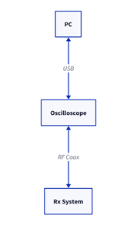

The microcontroller will use its Digital IO pins to turn LEDs on and off, for digital interrupts from the HMI, and send a pulse to the TX and oscilloscope portion of the system. The LEDs will be controlled by the outputs of the microcontroller. The pulse will be timed to be as short as possible, however to ensure accuracy that will feed into a timer circuit to keep the time consistent. Shown in figure 10.

Figure 10: Button interface to system

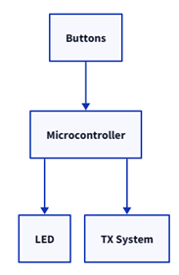

# EXTERNAL INTERFACES

With the system being self-contained there are no external interfaces under the scope of this PUD project, the only exception being the SD card containing the testing data. However, as this card is extracted from the PUD system manually by the operator this would only fit the definition of an external interface via the broadest possible interpretation of the term.

# SYSTEM INTEGRITY CONTROLS

The data collected by the PUD system is not inherently sensitive or private so security is not the highest priority. There will be a physical lock on the PUD outer casing for safety purposes but this will also protect the data the system collects. Physical protection of the device is the responsibility of the user of the system. Verification of the data will come from the lab that analyzes the data so this is not within the scope of the PUD project.

Table 2: electrical components parts list

| part number | Part specification and description |
| --- | --- |
| 1 | 3300 µF 500 V Aluminum Electrolytic Capacitors Radial, Can - Screw Terminals 54mOhm @ 100Hz 20000 Hrs @ 85°C |
| 2 | Enclosed DC DC Converter 1 Output 0 ~ 500V 20mA 13V Input  3838-HighVoltagePowerSupplyAHV12V500V20MAWTB-ND - Tape & Box (TB) |
| 3 | DC 12v 24v to 5v Step Down Converter Regulator 5A 25W Power Adapter Reducer for Car Electronics Truck Vehicle Boat Solar System (Accept DC 8-40V Inputs) |
| 4 | White, Cool 9000K LED Indication - Discrete 3.2V Radial |
| 5 | 5A & 10A 12V Smart Battery Charger with LCD Display for Lead Acid and Lithium (LiFePO4) Batteries |
| 6 | 6AWG (16mm²) 13 Inch Battery Interconnect Cable |
| 7 | LiFePO4 12V 50Ah Lithium Iron Phosphate Battery |
| 8 | Battery Isolator Switch for Car Vehicle RV and Marine (On/Off) |
| 9 | Ancor Marine Grade Primary Wire and Battery Cable |
| 10 | N-Channel 500 V 14A (Tc) 30W (Tc) Through Hole TO-220FP |
| 11 | Starelo 5pcs 19mm Momentary Push Button Switch Black Shell, IP65 Waterproof Push Button Switch,Stainless Steel 1 Normally Open Without LED. |
| 12 | 47 kOhms ±5% 50W Wirewound Chassis Mount Resistor |
| 13 | N-Channel 20 V 6.8A (Ta) 510mW (Ta), 6.94W (Tc) Surface Mount TO-236AB |
| 14 | 390 Ohms ±5% 0.5W, 1/2W Through Hole Resistor Axial Flame Retardant Coating, Safety Carbon Film |
| 15 | 21 Circuit 0.374" (9.50mm) Barrier Block Connector Screws |
| 16 | 5 A 600 V AC 500 V DC Fuse Cartridge, Ceramic Requires Holder 5mm x 20mm |
| 17 | Fuse Block 10 A 600V 1 Circuit Cartridge Chassis Mount |
| 18 | 6.3 A 250 V AC DC Fuse Cartridge, Glass Requires Holder 5mm x 20mm |
| 19 | ANSI Z535 Safety Labels - Hazardous Voltage Inside  Hazard labels with strong adhesive backing ideal for rugged use |
| 20 | 50ft - 1/4 inch & 1/2 inch PET Expandable Braided Sleeving – Black – Alex Tech Braided Cable Sleeve |
| 21 | XHF 3/4" Strong Back-Glue Self Adhesive Black Cable Zip Tie Mounts 100pcs with 8" Zip Ties, Screws, UV Protection Outdoor Sticky Wire Fasteners Cable Clips Management Anchors Organizer Holders Squares |
| 22 | Miuzei PCB Board Prototype Kit for Electronic Projects, Circuit Solder Double-Side Board with 40 Pin 2.54 mm Male to Female Headers Connector, 2P&3P Screw Terminal Block, Solder Flux, Solder Wire |
| 23 | 330 Pcs M2 Male Female Brass Hex Spacer Standoffs Screws Nuts, Brass Spacer Hex Column Screw Nut Assortment Kit, Threaded Pillar Standoffs Screws for PCB Circuit Board Motherboard Standoffs Spacer |
| 24 | Breadboard, Surface Mount Plated Surface Mount Pad (Square) 0.100" (2.54mm) |
| 25 | 2.7 kOhms ±5% 120W Wirewound Chassis Mount Resistor |
| 26 | Heat Sink TO-218, TO-220, TO-247 Aluminum 14.0W @ 70°C Board Level, Vertical  or  Heat Sink TO-220 Aluminum 2.5W @ 50°C Board Level |
| 27 | Belker Universal Laptop Car Charger with USB C for HP Dell Asus Lenovo Samsung MacBook Pro Air Google Chromebook Ultrabook Notebook |
| 28 | VELCRO Brand Extreme Outdoor Mounting Tape | 20Ft x 1 In, Holds 15 lbs | Strong Heavy Duty Stick on Adhesive | Mount on Brick, Concrete for Hanging, 30702 |
| 29 | Coolais 5 Pcs Momentary Push Button Switch Metal Waterproof Push Button Start 12mm 3A 250V AC PBSM-01 (Flat Head) |
| 30 | 3M Marine Adhesive Sealant Fast Cure 5200 (05220) Permanent Bonding and Sealing for Boats and RVs Above and Below the Waterline Waterproof Repair, White, 3 fl oz Tube |
| 31 | Temperature Sensor Analog, Local 5°C ~ 100°C 20mV/°C TO-92-3 |
| 32 | ASEV30 SERIES 30A DC CONTACTOR  Search Alert TSA Approved Travel Combination Luggage Cable Locks for Suitcase, Gym Locker,Toolbox,Backpack 1,2,4,6 &10 pk |
| 33 | E/FUSING 900 Moldable Silicone Putty - Black |
| 34 | 2Pcs Electronic Thermostat Controller W1209 DC 12V Digital Thermostat Waterproof Sensor Temperature Control Switch -50~110°C |
| 35 | TBD |

# References

“021706.3TXP Littelfuse Inc. | Circuit Protection | DigiKey.” *DigiKey*, www.digikey.com/en/products/detail/littelfuse-inc/021706-3TXP/3425317. Accessed 21 Oct. 2023.

“05200005ZXGY Littelfuse Inc. | Circuit Protection | DigiKey.” *DigiKey*, www.digikey.com/en/products/detail/littelfuse-inc/05200005ZXGY/554334. Accessed 21 Oct. 2023.

“0ADKC5000-Be Bel Fuse Inc. | Circuit Protection | Digikey.” *DigiKey*, www.digikey.com/en/products/detail/bel-fuse-inc/0ADKC5000-BE/7404459. Accessed 21 Oct. 2023.

“100ft - 1/2 Inch Pet Expandable Braided Sleeving - Amazon.Com.” *Amazon*, www.amazon.com/100ft-Expandable-Braided-Sleeving-braided/dp/B074GMNW7T. Accessed 21 Oct. 2023.

“12-48V Battery Isolator Switch for Car Vehicle RV and Marine (on/off): Eco-Worthy.” *ECO*, www.eco-worthy.com/products/12-48v-battery-isolator-switch-for-car-vehicle-rv-and-marine-on-off?variant=40589578567868. Accessed 21 Oct. 2023.

“2-1546306-1 TE Connectivity AMP Connectors - DigiKey Electronics.” *DigiKey*, www.digikey.com/en/products/detail/te-connectivity-amp-connectors/2-1546306-1/1136667. Accessed 21 Oct. 2023.

“330 PCS M2 Male Female Brass Hex Spacer Standoffs Screws ... - Amazon.Com.” *Amazon*, www.amazon.com/Standoffs-Assortment-Threaded-Circuit-Motherboard/dp/B0BZYTC581. Accessed 21 Oct. 2023.

“577002B00000G Aavid, Thermal Division of Boyd Corporation - Digikey.” *DigiKey*, www.digikey.com/en/products/detail/aavid-thermal-division-of-boyd-corporation/577002B00000G/102507. Accessed 21 Oct. 2023.

“5A 12V Automatic Smart Battery Charger and Maintainer with LCD Display for Lead Acid and Lithium (LiFePO4) Batteries: Eco-Worthy.” *ECO*, www.eco-worthy.com/products/5a-12v-automatic-smart-battery-charger-and-maintainer-with-lcd-display-for-lead-acid-and-lithium-lifepo4-batteries?variant=42350017052921. Accessed 21 Oct. 2023.

“6AWG (16mm2) 13 Inch Battery Interconnect Cable: Eco-Worthy.” *ECO*, www.eco-worthy.com/products/6awg-16mm-13-inch-battery-interconnect-cable?variant=34593133625509. Accessed 21 Oct. 2023.

“Als30a332np500 Kemet | Capacitors | Digikey - Digi-Key Electronics.” *Digikey*, www.digikey.com/en/products/detail/kemet/ALS30A332NP500/3462159. Accessed 21 Oct. 2023.

“Amazon.Com: 2Pcs Electronic Thermostat Controller W1209 DC 12V Digital ...” *Amazon*, www.amazon.com/Electronic-Thermostat-Controller-Waterproof-Temperature/dp/B08Y6L34PX. Accessed 4 Feb. 2024.

“Amazon.Com: Tsa Approved Luggage Locks, Travel Locks Which Also Work ...” *Amazon*, www.amazon.com/Approved-Luggage-Travel-Toolbox-Backpack/dp/B07MVJZ6C2. Accessed 4 Feb. 2024.

“Amazon.Com: XHF 3/4" Strong Back-Glue Self Adhesive Black Cable Zip Tie ...” *Amazon*, www.amazon.com/XHF-Back-Glue-Protection-Fasteners-Management/dp/B08F77YVYB. Accessed 21 Oct. 2023.

“ANCOR Marine Grade Primary Wire and Battery Cable - Amazon.Com.” *Amazon*, www.amazon.com/Ancor-Marine-Grade-Primary-Battery/dp/B07ZSDK651. Accessed 21 Oct. 2023.

“ANSI Z535 Safety Labels - Hazardous Voltage Inside.” *Seton*, www.seton.com/ansi-z535-safety-labels-hazardous-voltage-inside-l5476.html?utm_campaign=%5BNB%5D_Labels_Catch%2BAll_PLA-S_High_All_PC-02_GGL_SUS&utm_source=google&utm_medium=cpc&utm_term=&matchtype=&device=c&adgroupid=&gclsrc=aw.ds&gclid=CjwKCAjwseSoBhBXEiwA9iZtxo15KyzhNfMKE5oyzbC-vorhbGmpge9ewSppeK7ReCrhPLgh6Yt0NRoCVhcQAvD_BwE. Accessed 21 Oct. 2023.

“ASEV30-B Altran Magnetics, LLC | Relays | Digikey.” *DigiKey*, www.digikey.com/en/products/detail/altran-magnetics-llc/ASEV30-B/14120027. Accessed 4 Feb. 2024.

“C503C-Wan-CCADB232 Creeled, Inc. | Optoelectronics | DigiKey.” *DigiKey*, www.digikey.com/en/products/detail/creeled-inc/C503C-WAN-CCADB232/2681196. Accessed 21 Oct. 2023.

“CF12JT390R Stackpole Electronics Inc | Resistors | Digikey.” *DigiKey*, www.digikey.com/en/products/detail/stackpole-electronics-inc/CF12JT390R/1741140. Accessed 21 Oct. 2023.

“DC 12V 24V to 5V Step down Converter Regulator 5A 25W Power Adapter ...” *Amazon*, www.amazon.com/Converter-Regulator-Adapter-Reducer-Electronics/dp/B07Q5W1BG3. Accessed 21 Oct. 2023.

“Dolby Vision + Dolby Atmos - Amazon.Com.” *Amazon*, www.amazon.com/Hisense-Premium-50U6G1-Quantum-Compatible/dp/B09TWYDMPY. Accessed 4 Feb. 2024.

“E/Fusing 900 Moldable Silicone Putty - Black - Amazon.Com.” *Amazon*, www.amazon.com/E-FUSING-900/dp/B0B6JWT295. Accessed 4 Feb. 2024.

“High Voltage Power Supply AHV12V500V20MAW Analog Technologies | Power ...” *DigiKey*, www.digikey.com/en/products/detail/analog-technologies/High-Voltage-Power-Supply-AHV12V500V20MAW/18621897. Accessed 21 Oct. 2023.

“HTTPS: //WWW. Amazon. COM/GP/Product/B00955337I/Ref=oh_aui_detailpage ...” *Amazon*, www.amazon.com/gp/customer-reviews/R2WSHBZW6W1Z0K/. Accessed 4 Feb. 2024.

“HTTPS: //WWW. Amazon. COM/GP/Product/B00955337I/Ref=oh_aui_detailpage ...” *Amazon*, www.amazon.com/gp/customer-reviews/R2WSHBZW6W1Z0K/. Accessed 4 Feb. 2024.

“LiFePO4 12V 50ah Lithium Iron Phosphate Battery: Eco-Worthy.” *ECO*, www.eco-worthy.com/products/lifepo4-12v-50ah-lithium-iron-phosphate-battery?currency=USD&variant=42491122712825&utm_medium=cpc&utm_source=google&utm_campaign=Google+Shopping&stkn=ac7b7d784bf0&gclid=CjwKCAjwgsqoBhBNEiwAwe5w02e_e41oUWis8aF0zZ64SqB2gfhDZQGvhFikRSAGGwQNgwVP8l8POBoCaacQAvD_BwE. Accessed 21 Oct. 2023.

“Miuzei PCB Board Prototype Kit for Electronic Projects, Circuit Solder ...” *Amazon*, www.amazon.com/Miuzei-Including-Prototype-Connector-Terminal/dp/B07PS4VCDD. Accessed 21 Oct. 2023.

“Ohmite Distributor | DigiKey Electronics.” *DigiKey*, www.digikey.com/en/supplier-centers/ohmite. Accessed 21 Oct. 2023.

“PMV16XNR Nexperia USA Inc. | Discrete Semiconductor Products | DigiKey.” *DigiKey*, www.digikey.com/en/products/detail/nexperia-usa-inc/PMV16XNR/5395791. Accessed 21 Oct. 2023.

“Ra-T2X-38E Ohmite | Fans, Thermal Management | DigiKey.” *DigiKey*, www.digikey.com/en/products/detail/ohmite/RA-T2X-38E/2416488. Accessed 21 Oct. 2023.

“SBBSM2106-1 Chip Quik Inc. | Prototyping, Fabrication Products | DigiKey.” *DigiKey*, www.digikey.com/en/products/detail/chip-quik-inc/SBBSM2106-1/5978238. Accessed 21 Oct. 2023.

“Starelo 5pcs 12mm Momentary Push Button Switch Black Shell with Pre ...” *Amazon*, www.amazon.com/Momentary-Push-Button-Switch-Without/dp/B09BKZ68HF. Accessed 21 Oct. 2023.

“STF19NM50N Stmicroelectronics | Discrete Semiconductor Products | DigiKey.” *DigiKey*, www.digikey.com/en/products/detail/stmicroelectronics/STF19NM50N/2346299. Accessed 21 Oct. 2023.

“TE120B2K7J Te Connectivity Passive Product | Resistors | DigiKey.” *DigiKey*, www.digikey.com/en/products/detail/te-connectivity-passive-product/TE120B2K7J/14308543. Accessed 21 Oct. 2023.

“TMP37FT9Z Analog Devices Inc. | Sensors, Transducers | DigiKey.” *DigiKey*, www.digikey.com/en/products/detail/analog-devices-inc/TMP37FT9Z/1217626. Accessed 4 Feb. 2024.